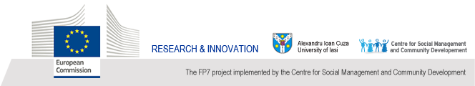

WOMEN RESEARCHERS DAY:
CELEBRATION OF THE UAIC WOMEN IN SCIENCE
Second edition, 28 March 2014

Organized by the Center for Social Management and Community Development, the UAIC’s Center for Gender Equality in Science and the UAIC’s Network of Women in Academics and Research, within the frame of FP7 European project STAGES – “Structural Transformation to Achieve Gender Equality in Science”.
Programme

Ceremony of Scientific Excellence Awards 2014 (Senate Hall, 28 March, 10:00-12:00)

- Opening speech: Prof. univ. dr. Vasile Ișan, Rector of the “Alexandru Ioan Cuza” University of Iasi, Romania
- Women and Scientific Excellence in Life and Earth sciences - a brief overview. Moderator: Prof. univ. dr. Doina Balahur, Director of the UAIC Centre for Gender Equality in Science, coordinator of the UAIC-STAGES project
- Film presentation: “UAIC Profiles of Women in Science (2). Life and Earth sciences”. Prof. dr. Elena Bâcu and Prof. dr. Alexandra-Raluca Iordan (Chemistry), Conf. dr. Luminița Bejenaru, Conf. dr. Zenovia Olteanu and Prof. dr. Maria-Magdalena Zamfirache (Biology), Conf. dr. Iuliana Breabăn (Geography-Geology) and young researchers groups from the Faculties of Chemistry, Biology and Geography–Geology.
- The official ceremony “Women’s Annual Science and Technology Excellence Awards 2014” and “Women’s Annual Science and Technology Distinctions for Young Researchers 2014”

Research networks in Europe. International video-workshop for early career researchers and PhD students (Senate Hall, 28 March, 14:00-16:00)

With the online participation of the CNRS-France (direction Mission for the Place of Women) and several European universities involved in FP7 projects on Gender Equality in Science.

All are welcome

